Objectives:

* Designing a Login form that authenticates to a database called Derby
* Importing Derby Drivers
* Creating Derby Databases & Tables
* Writing code for: Select, Insert, Update and Delete Statements
* Creating the JTable and Importing the JTable Driver
* JList, JMenuBar, JMenu & JMenuItem
* Global Variables

**There are 7 print screens/code copy, each worth 14.2%**

1. Click on the File Menu >> New Project >> Chose default and click on next
2. Name the project to >> **Week 6** **Database Info**
   1. Click on the browse button and place it in the folder desired
3. To access the database, click on the services tab



1. To start the database right click on the JAVA DB and click on start

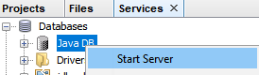

1. To create a new database right click on the JAVA DB again, and click on Create New Database

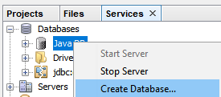

1. Enter the following: the password enter sac123

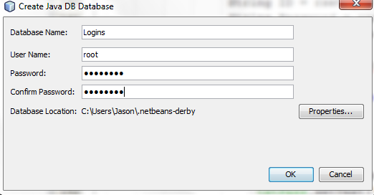

1. You should see the new driver as highlighted below
2. Right click on the new Driver and click on connect
   1. Expand the driver and under ROOT, right click on the tables icon and choose Create Table

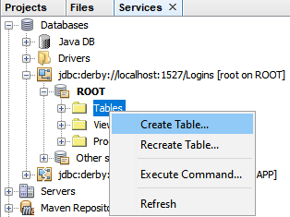

* 1. Type in LoginsTable as the table name

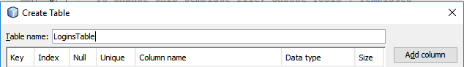

* 1. Then click on the Add column and enter the following information:

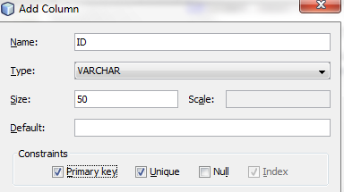

1. Add a 2nd column and type Password as shown below:

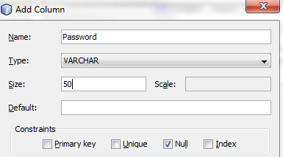

1. When completed you should see the new Table

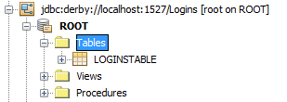

1. To enter data right click on the table >>>> View Data >>>> Click on ICONto insert new records
2. Insert the following records below and when completed click OK.

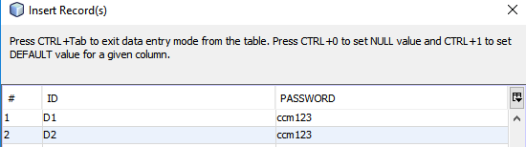

1. Switch to the Projects TAB

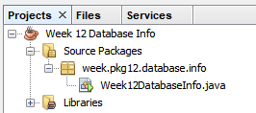

1. Right click on the package and choose JFrame Form

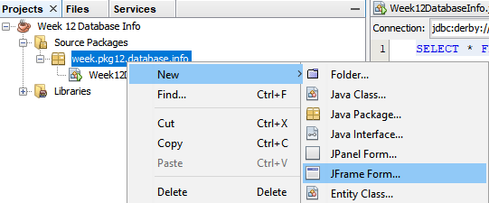

1. Type in Logins for the name of the form

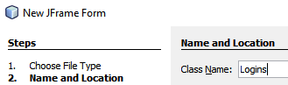

1. Download the Derby & JTable drivers from Black Board
2. Import the drivers by right clicking on the Libraries Folder >>>> Add Jar >>>> Locate where you downloaded the file and add it

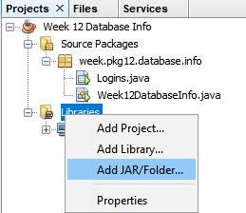

When completed it should look like this below

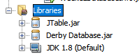

1. Now, it’s time to design the form, click and drag two labels, text fields and buttons as shown below.

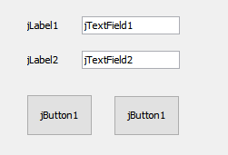

1. Edit the labels by right clicking and edit text.

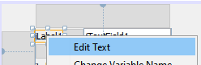

1. Edit the text fields by right clicking and edit text and delete the text



1. To rename a new variable for the text fields, right click on the text field and click on Change Variable Name

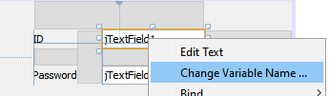

1. Change the variable name for the text field to >> txtID

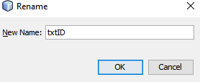

1. Change the 2nd text field to >> txtPass
2. Edit the text for the buttons as shown below:

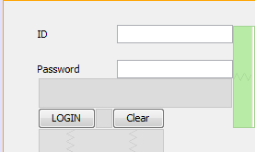

## Double click on the Login button and scroll to the top and under the bottom of the class type the following (See arrow)

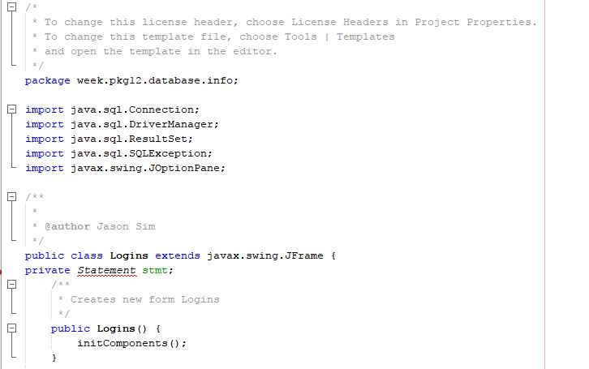

***The Statement class will allow us to write SQL Statements***

1. Import the Statement class for SQL & NOT beans

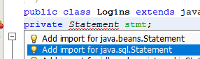

1. Under the button control type the following:

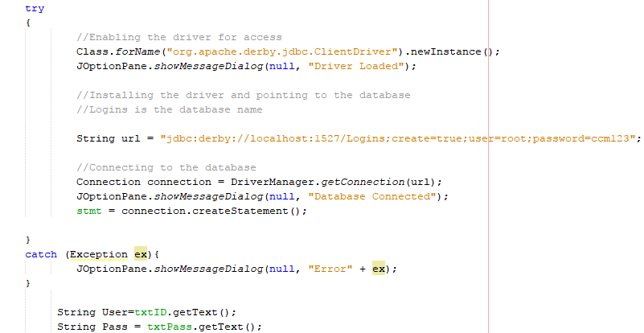

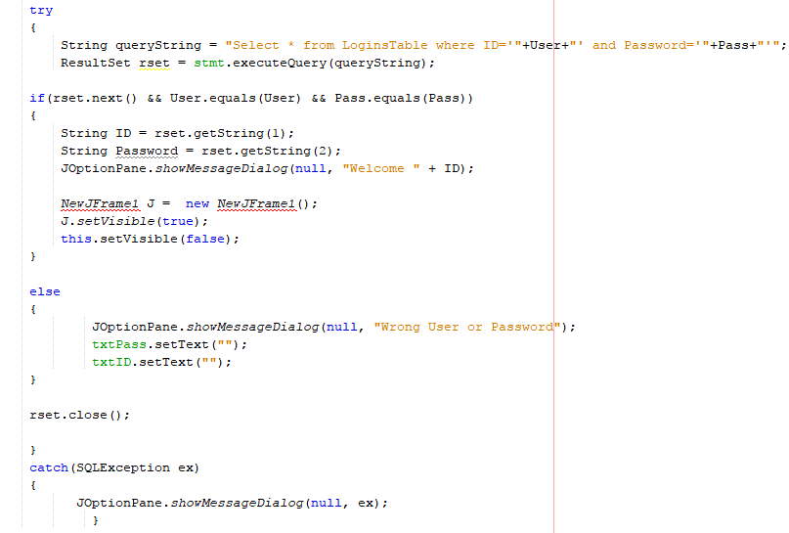

1. Create a second JFrame by right clicking on the package >>> New >>>>JFrame Form. Name it >>>> **NewJFrame1**
2. Before proceeding, test the application & click on the login button

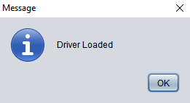

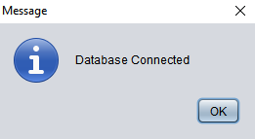

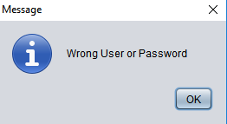

1. Now, type in the correct ID with password

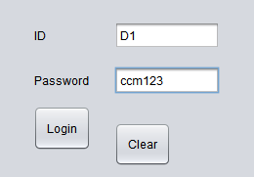

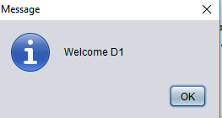

1. Comment out all the message boxes EXCEPT the ones in the IF statement
2. Run the program again
3. On the 2nd Frame design as shown below:
   1. 1 Table
   2. 4 Buttons
   3. 2 Labels
   4. 2 Text Fields >>> change the variable for the ID text field to >>>> txtID & Password field to >>>> txtPass

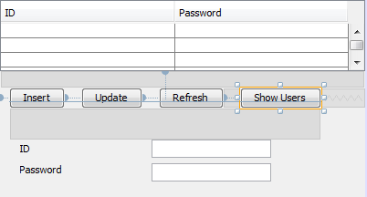

1. Click and Drag a table from the tools, and for the table, right click on the table >>>> Table Contents >>>> Columns >>>> Create the two columns and delete the last two columns

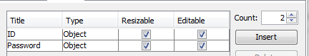

1. Double click on the Insert button and copy and paste the following connection code (**this is the same connection code from the Login form**) under the InitComponents() which will automatically execute the code

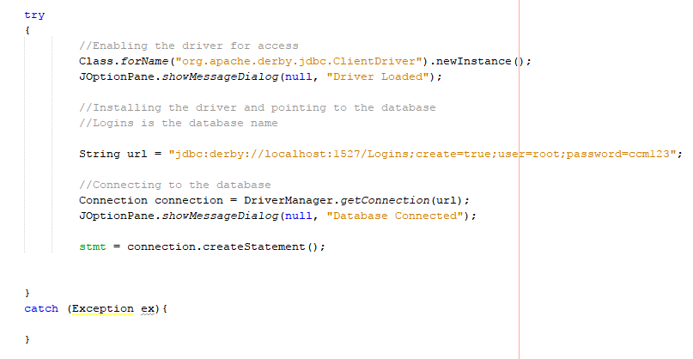

1. Double click on the Show Users button and type the following to extract from the database to the JTable

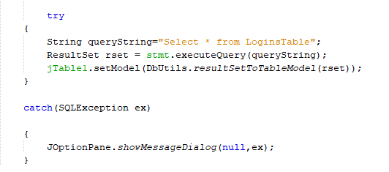

1. Run the app and you will see the following:

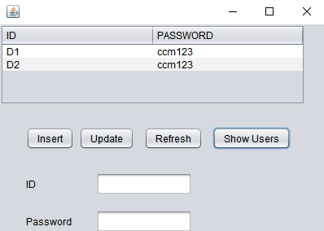

1. To update the table

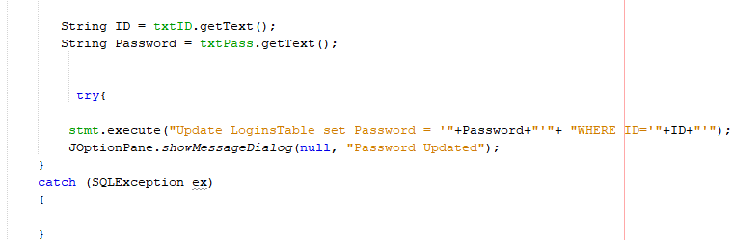

Execute the app and type in the following into the text fields

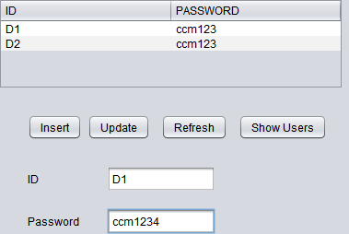

1. Double click on the Refresh button

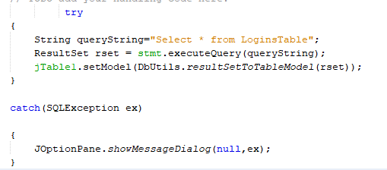

1. Double click on the Insert button and copy and paste the following code:

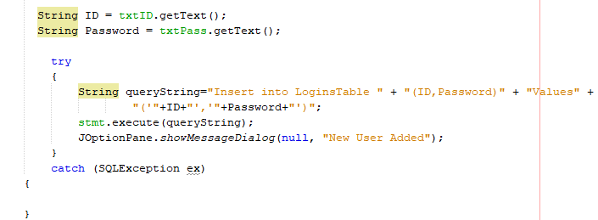

1. Now finally, double click on the clear button

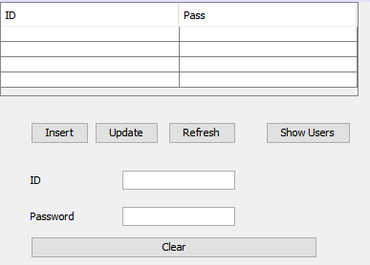

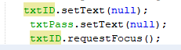

1. Test all button controls

Beginning here is the beginning of the class exercises

1. Create a new Class and type in the following code below:

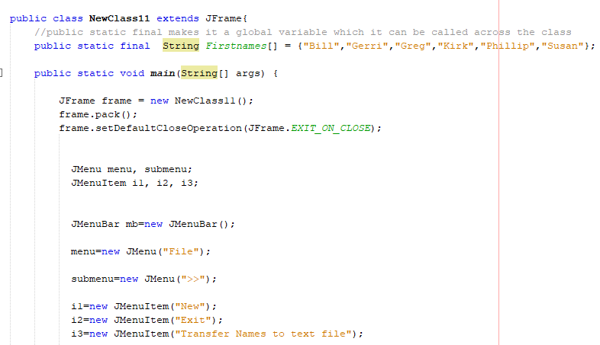

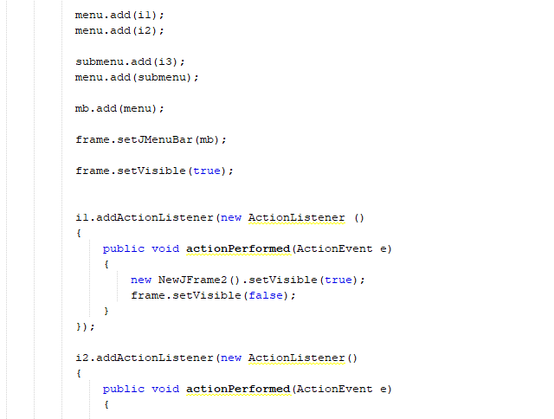

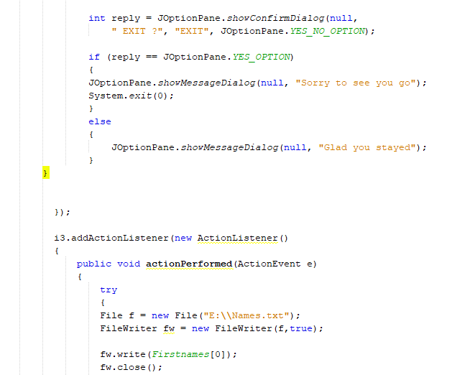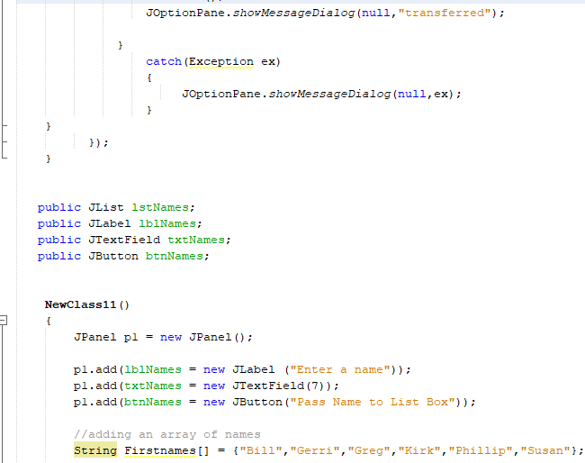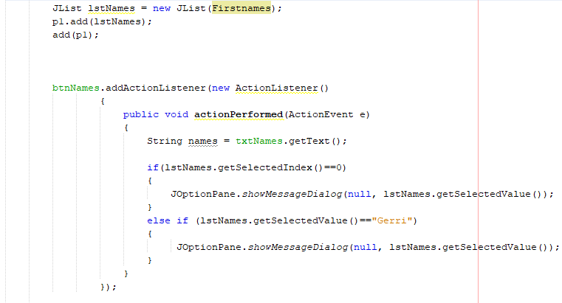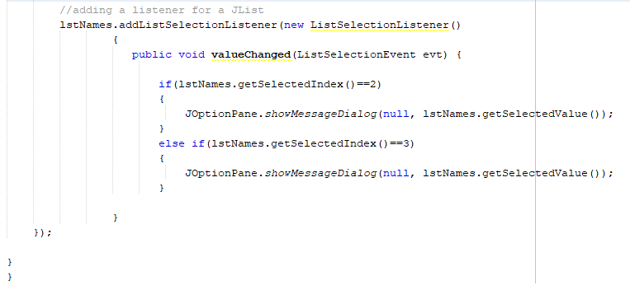

Finally, we will create a **DefaultListModel** (See highlighted) above the btnNames JButton

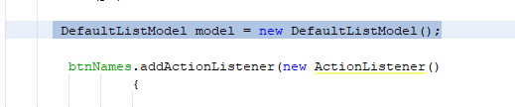

A default list model shows the list-box and data in a List format

Under the else if statement (see highlighted) portion call the model to populate names from the Text Field

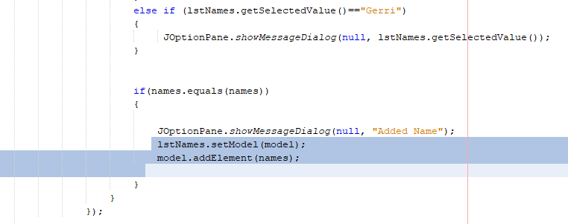

**Class Exercise #1**

For the Firstnames Array, add to the program so all names will be transferred to the text file.

**#1 print screen only the code added below here**

package week.pkg7;

import java.awt.event.ActionEvent;

import java.awt.event.ActionListener;

import java.io.File;

import java.io.FileWriter;

import javax.swing.JOptionPane;

import javax.swing.JFrame;

import javax.swing.*;

public class NewClass extends JFrame{

public static final String Firstnames[] = {"Bill", "Gerri", "Greg", "Kirk", "Phillip", "Susan"};

public static void main(String[] args) {

JFrame frame = new NewClass();

frame.pack();

frame.setDefaultCloseOperation(JFrame.EXIT_ON_CLOSE);

JMenu menu, submenu;

JMenuItem i1, i2, i3;

JMenuBar mb = new JMenuBar();

menu = new JMenu("File");

submenu = new JMenu(">>");

i1 = new JMenuItem("New");

i2 = new JMenuItem("Exit");

i3 = new JMenuItem("Transfer Names to text file");

menu.add(i1);

menu.add(i2);

submenu.add(i3);

menu.add(submenu);

mb.add(menu);

frame.setJMenuBar(mb);

frame.setVisible(true);

i1.addActionListener(new ActionListener ()

{

public void actionPerformed(ActionEvent e)

{

new NewJFrame2().setVisible(true);

frame.setVisible(false);

}

});

i2.addActionListener(new ActionListener ()

{

public void actionPerformed(ActionEvent e)

{

int reply = JOptionPane.showConfirmDialog(null, " EXIT ?", "EXIT", JOptionPane.YES_NO_OPTION);

if (reply == JOptionPane.YES_OPTION)

{

JOptionPane.showMessageDialog(null, "Sorry to see you go");

System.exit(0);

}

else

{

JOptionPane.showMessageDialog(null, "Glad you stayed");

}

}

});

i3.addActionListener(new ActionListener ()

{

public void actionPerformed(ActionEvent e)

{

try

{

File f = new File("D:\\CMPR 113\\Week 7\\code\\Names.txt");

FileWriter fw = new FileWriter(f,true);

fw.write(Firstnames[0]);

fw.close();

JOptionPane.showMessageDialog(null,"Transferred");

}

catch(Exception ex)

{

JOptionPane.showMessageDialog(null,ex);

}

}

});

}

public JList lstNames;

public JLabel lblNames;

public JTextField txtNames;

DefaultListModel model = new DefaultListModel();

public JButton btnNames;

NewClass()

{

JPanel p1 = new JPanel();

p1.add(lblNames = new JLabel ("Enter a name"));

p1.add(txtNames = new JTextField(7));

p1.add(btnNames = new JButton("Pass Name to List Box"));

String Firstnames[] = {"Bill", "Gerri", "Greg", "Kirk", "Phillip", "Susan"};

JList lstNames = new JList(Firstnames);

p1.add(lstNames);

add(p1);

btnNames.addActionListener(new ActionListener()

{

public void actionPerformed(ActionEvent e)

{

String names = txtNames.getText();

if(lstNames.getSelectedIndex() == 0)

{

JOptionPane.showMessageDialog(null, lstNames.getSelectedValue());

}

else if (lstNames.getSelectedIndex() == 3)

{

JOptionPane.showMessageDialog(null, lstNames.getSelectedValue());

}

else if (lstNames.getSelectedValue() == "Gerri")

{

JOptionPane.showMessageDialog(null, lstNames.getSelectedValue());

}

if (names.equals(names))

{

JOptionPane.showMessageDialog(null, "Added name");

lstNames.setModel(model);

model.addElement(names);

}

}

});

}

}

**#2 open the text file and print screen below here**

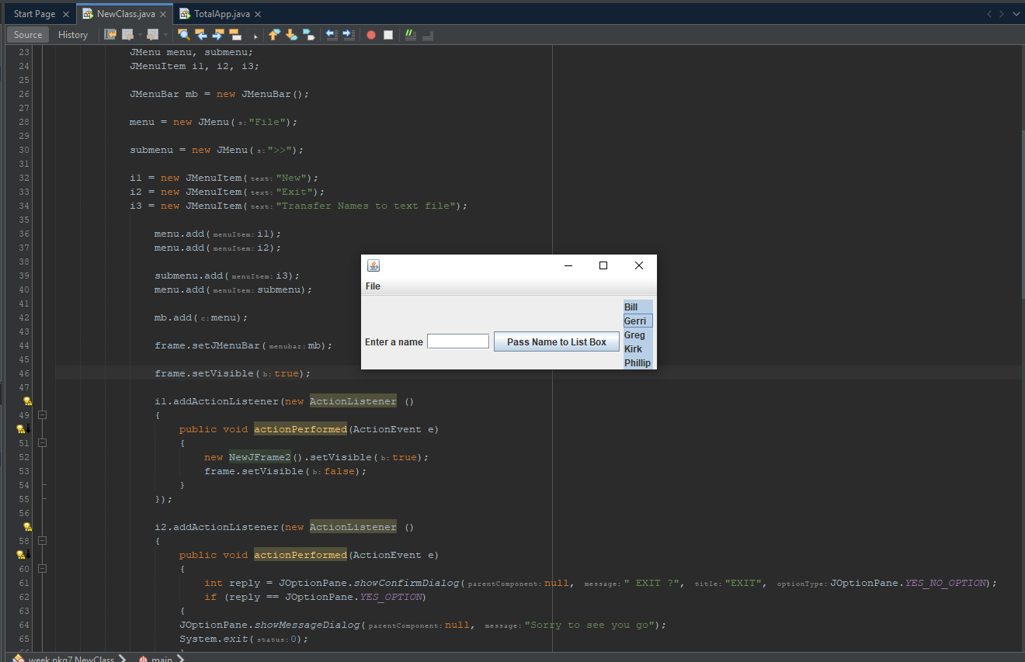

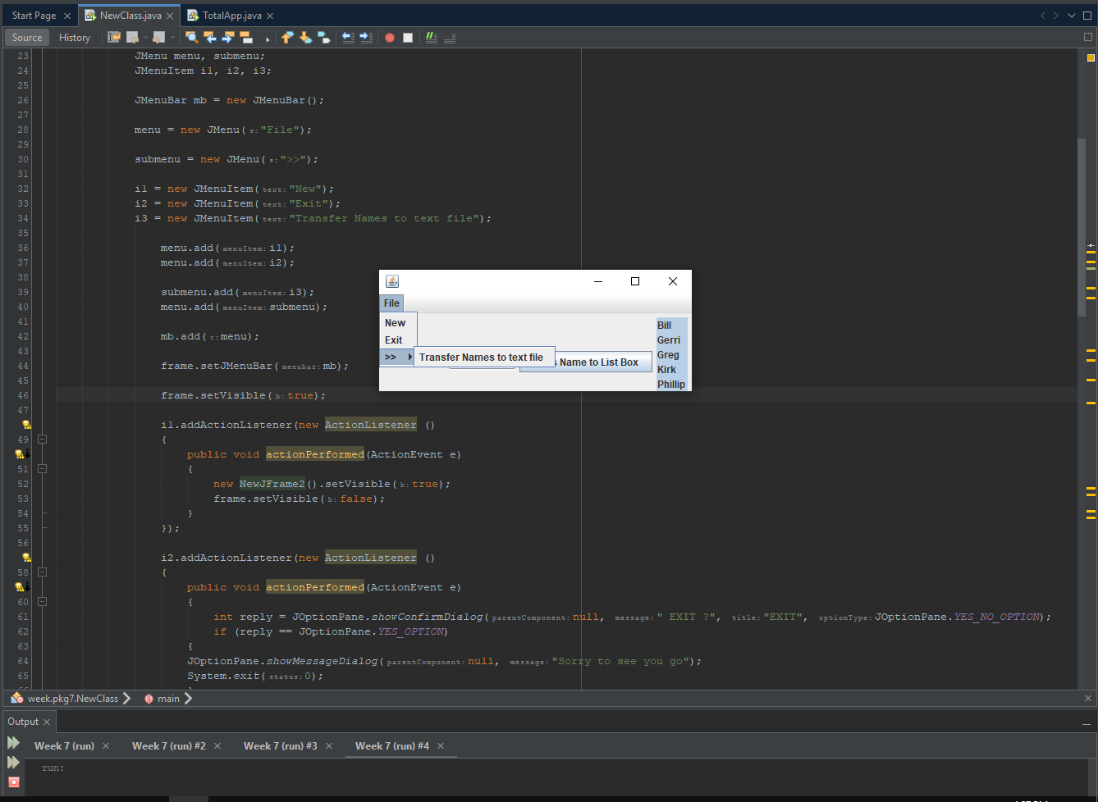

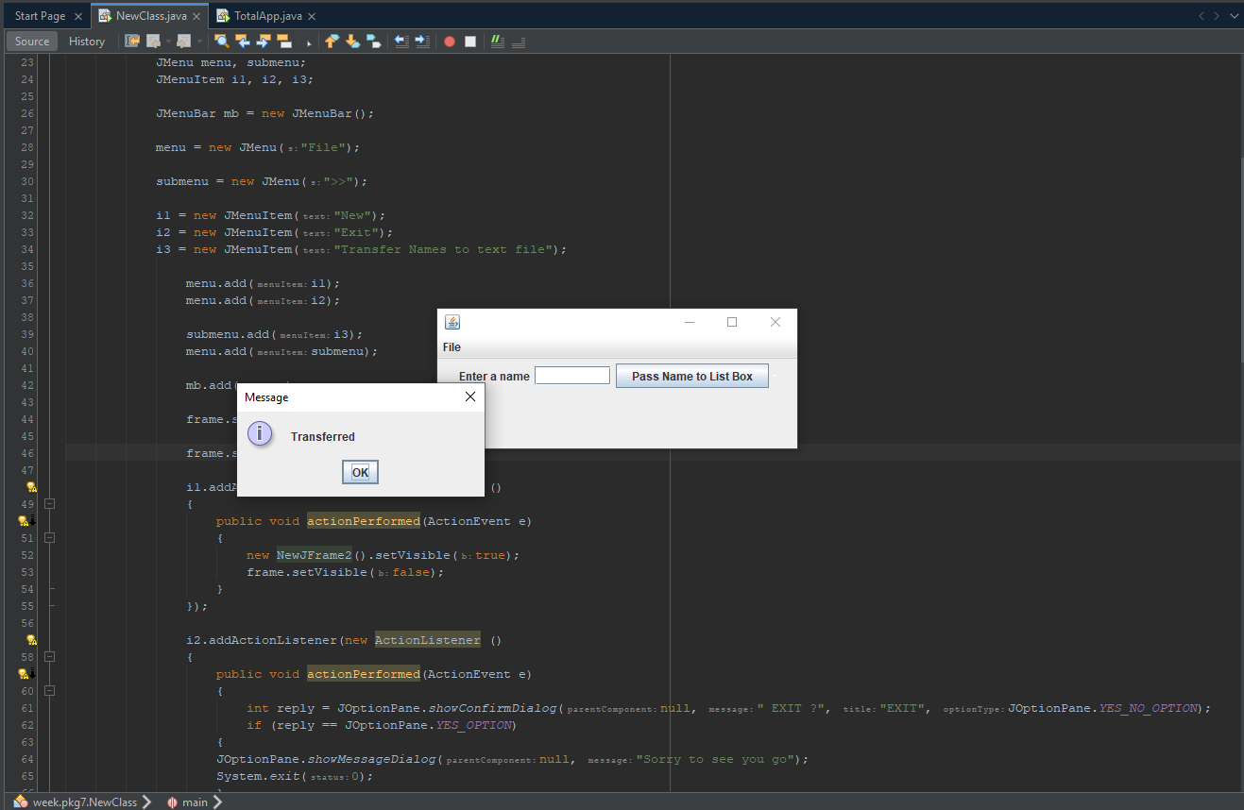

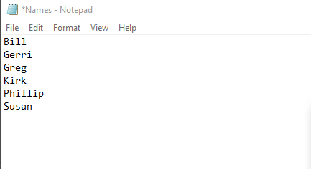

**Class Exercise #2**

When the File >> New menu item is clicked on the new form create the following class below (**TotalApp)** class Jframe

Objectives:

* Creating a Sales Tax App in console
* Converting the console in GUI using code

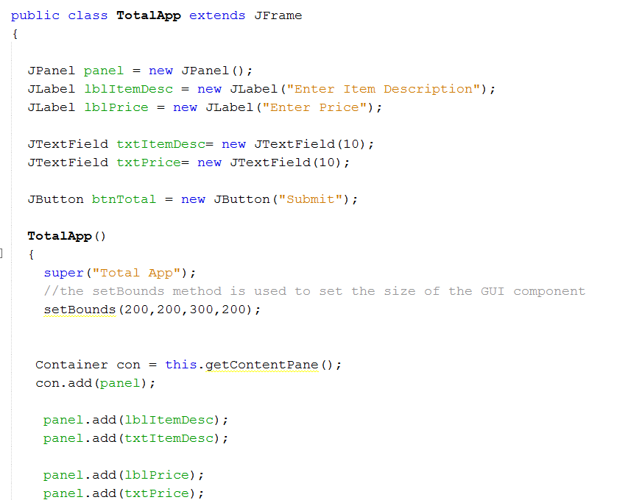

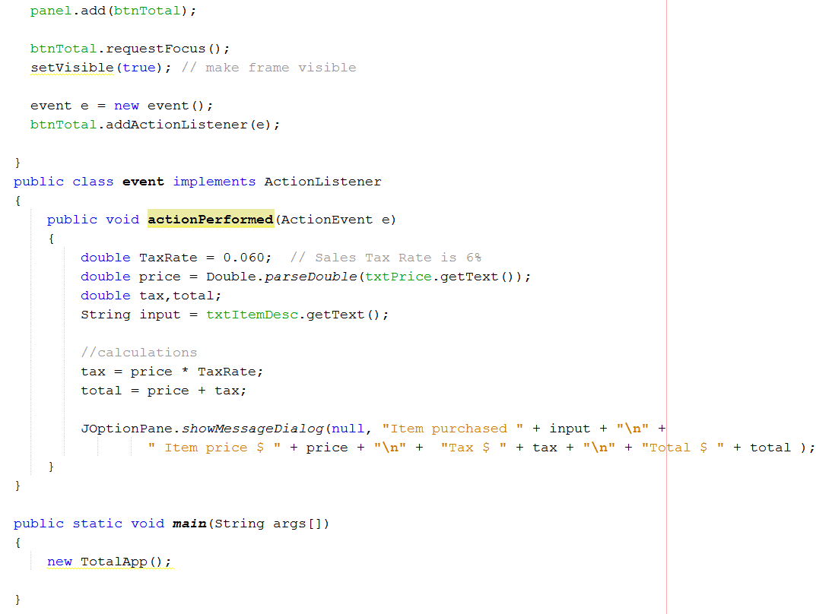

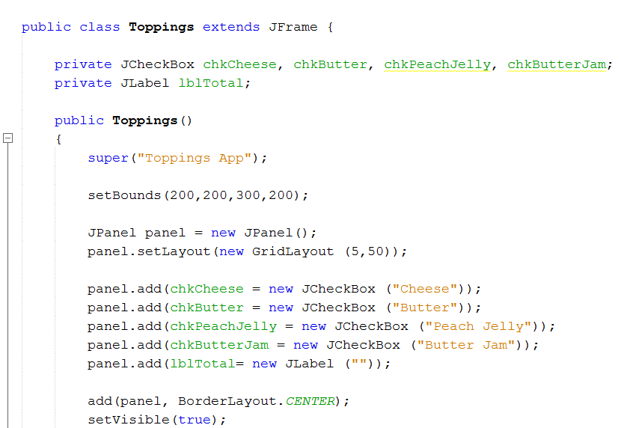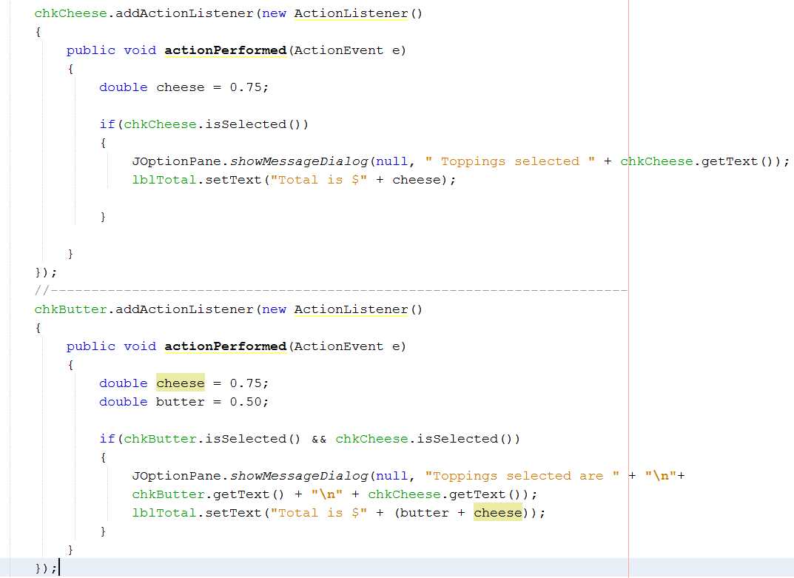

**#3 print screen the running app below here**

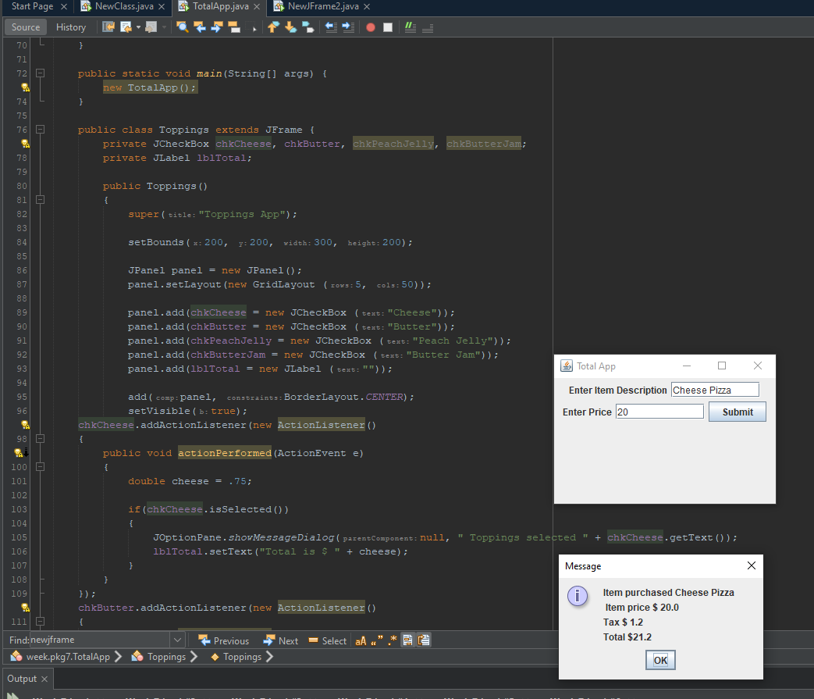

**#4 copy and paste the code below here**

package week.pkg7;

import java.awt.BorderLayout;

import java.awt.Container;

import java.awt.GridLayout;

import java.awt.event.ActionEvent;

import java.awt.event.ActionListener;

import javax.swing.JButton;

import javax.swing.JCheckBox;

import javax.swing.JFrame;

import javax.swing.JLabel;

import javax.swing.JOptionPane;

import javax.swing.JPanel;

import javax.swing.JTextField;

import static sun.net.www.http.HttpClient.New;

public class TotalApp extends JFrame{

JPanel panel = new JPanel();

JLabel lblItemDesc = new JLabel("Enter Item Description");

JLabel lblPrice = new JLabel("Enter Price");

JTextField txtItemDesc = new JTextField(10);

JTextField txtPrice = new JTextField(10);

JButton btnTotal = new JButton("Submit");

TotalApp()

{

super("Total App");

setBounds(200, 200, 300, 200);

Container con = this.getContentPane();

con.add(panel);

panel.add(lblItemDesc);

panel.add(txtItemDesc);

panel.add(lblPrice);

panel.add(txtPrice);

panel.add(btnTotal);

btnTotal.requestFocus();

setVisible(true);

event e = new event();

btnTotal.addActionListener(e);

}

public class event implements ActionListener

{

public void actionPerformed(ActionEvent e)

{

double TaxRate = .060;

double price = Double.parseDouble(txtPrice.getText());

double tax, total;

String input = txtItemDesc.getText();

tax = price * TaxRate;

total = price + tax;

JOptionPane.showMessageDialog(null, "Item purchased " + input + "\n" +

" Item price $ " + price + "\n" + "Tax $ " + tax + "\n" + "Total $" + total);

}

}

public static void main(String[] args) {

new TotalApp();

}

public class Toppings extends JFrame {

private JCheckBox chkCheese, chkButter, chkPeachJelly, chkButterJam;

private JLabel lblTotal;

public Toppings()

{

super("Toppings App");

setBounds(200, 200, 300, 200);

JPanel panel = new JPanel();

panel.setLayout(new GridLayout (5, 50));

panel.add(chkCheese = new JCheckBox ("Cheese"));

panel.add(chkButter = new JCheckBox ("Butter"));

panel.add(chkPeachJelly = new JCheckBox ("Peach Jelly"));

panel.add(chkButterJam = new JCheckBox ("Butter Jam"));

panel.add(lblTotal = new JLabel (""));

add(panel, BorderLayout.CENTER);

setVisible(true);

chkCheese.addActionListener(new ActionListener()

{

public void actionPerformed(ActionEvent e)

{

double cheese = .75;

if(chkCheese.isSelected())

{

JOptionPane.showMessageDialog(null, " Toppings selected " + chkCheese.getText());

lblTotal.setText("Total is $ " + cheese);

}

}

});

chkButter.addActionListener(new ActionListener()

{

public void actionPerformed(ActionEvent e)

{

double cheese = .75;

double butter = .5;

if(chkButter.isSelected() && chkCheese.isSelected())

{

JOptionPane.showMessageDialog(null, "Toppings selected are " + "\n" +

chkButter.getText() + "\n" + chkCheese.getText());

lblTotal.setText("Total is $" + (butter + cheese));

}

}

});

}

}

}

**Exercise #3**

For the **TotalApp** class, create a menu and label as **menu** and a sub-menu item and name it **Transfer File** and transfer the output to a text file

**#5 print screen the running app below here**

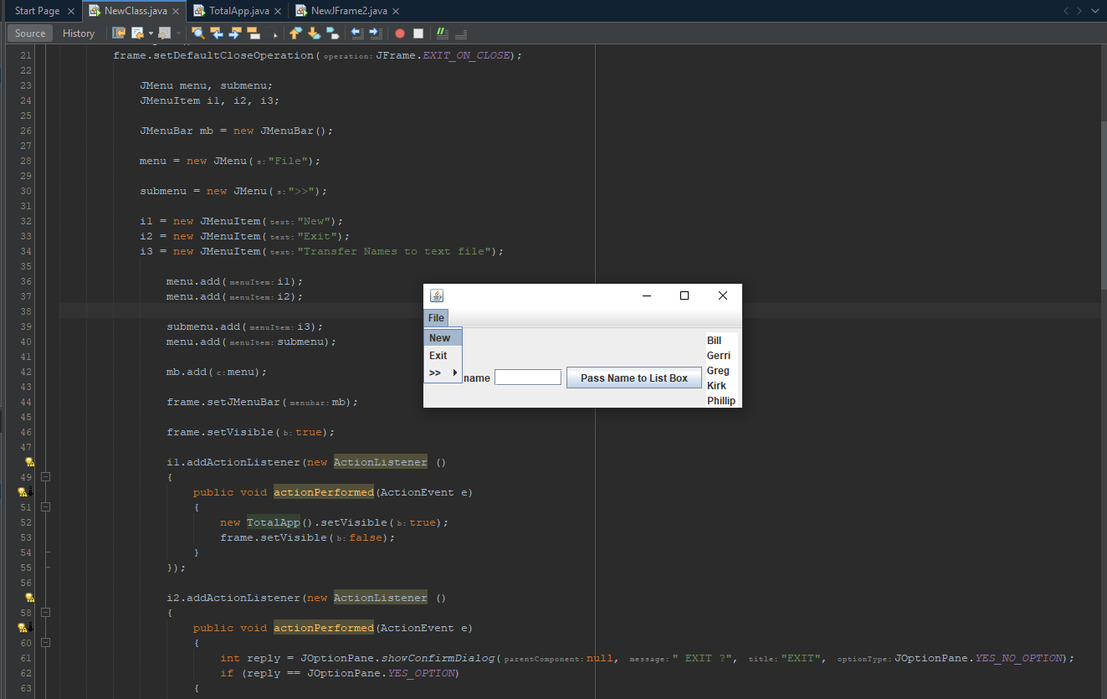

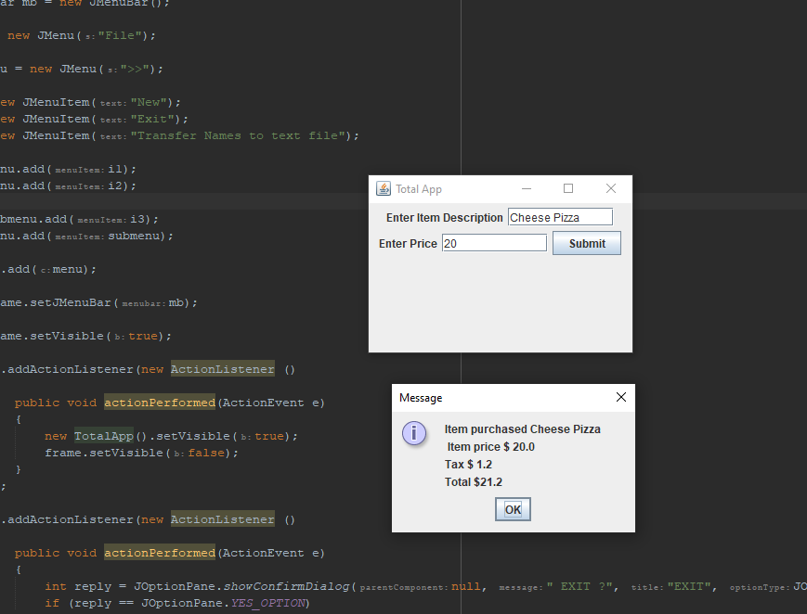

**#6 Open the text file and print screen below here**

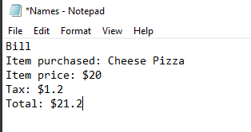

**#7 copy and paste the code for the TotalApp class below here**

**package week.pkg7;**

**import java.awt.BorderLayout;**

**import java.awt.Container;**

**import java.awt.GridLayout;**

**import java.awt.event.ActionEvent;**

**import java.awt.event.ActionListener;**

**import javax.swing.JButton;**

**import javax.swing.JCheckBox;**

**import javax.swing.JFrame;**

**import javax.swing.JLabel;**

**import javax.swing.JOptionPane;**

**import javax.swing.JPanel;**

**import javax.swing.JTextField;**

**import static sun.net.www.http.HttpClient.New;**

**public class TotalApp extends JFrame{**

**JPanel panel = new JPanel();**

**JLabel lblItemDesc = new JLabel("Enter Item Description");**

**JLabel lblPrice = new JLabel("Enter Price");**

**JTextField txtItemDesc = new JTextField(10);**

**JTextField txtPrice = new JTextField(10);**

**JButton btnTotal = new JButton("Submit");**

**TotalApp()**

**{**

**super("Total App");**

**setBounds(200, 200, 300, 200);**

**Container con = this.getContentPane();**

**con.add(panel);**

**panel.add(lblItemDesc);**

**panel.add(txtItemDesc);**

**panel.add(lblPrice);**

**panel.add(txtPrice);**

**panel.add(btnTotal);**

**btnTotal.requestFocus();**

**setVisible(true);**

**event e = new event();**

**btnTotal.addActionListener(e);**

**}**

**public class event implements ActionListener**

**{**

**public void actionPerformed(ActionEvent e)**

**{**

**double TaxRate = .060;**

**double price = Double.parseDouble(txtPrice.getText());**

**double tax, total;**

**String input = txtItemDesc.getText();**

**tax = price * TaxRate;**

**total = price + tax;**

**JOptionPane.showMessageDialog(null, "Item purchased " + input + "\n" +**

**" Item price $ " + price + "\n" + "Tax $ " + tax + "\n" + "Total $" + total);**

**}**

**}**

**public static void main(String[] args) {**

**new TotalApp();**

**}**

**public class Toppings extends JFrame {**

**private JCheckBox chkCheese, chkButter, chkPeachJelly, chkButterJam;**

**private JLabel lblTotal;**

**public Toppings()**

**{**

**super("Toppings App");**

**setBounds(200, 200, 300, 200);**

**JPanel panel = new JPanel();**

**panel.setLayout(new GridLayout (5, 50));**

**panel.add(chkCheese = new JCheckBox ("Cheese"));**

**panel.add(chkButter = new JCheckBox ("Butter"));**

**panel.add(chkPeachJelly = new JCheckBox ("Peach Jelly"));**

**panel.add(chkButterJam = new JCheckBox ("Butter Jam"));**

**panel.add(lblTotal = new JLabel (""));**

**add(panel, BorderLayout.CENTER);**

**setVisible(true);**

**chkCheese.addActionListener(new ActionListener()**

**{**

**public void actionPerformed(ActionEvent e)**

**{**

**double cheese = .75;**

**if(chkCheese.isSelected())**

**{**

**JOptionPane.showMessageDialog(null, " Toppings selected " + chkCheese.getText());**

**lblTotal.setText("Total is $ " + cheese);**

**}**

**}**

**});**

**chkButter.addActionListener(new ActionListener()**

**{**

**public void actionPerformed(ActionEvent e)**

**{**

**double cheese = .75;**

**double butter = .5;**

**if(chkButter.isSelected() && chkCheese.isSelected())**

**{**

**JOptionPane.showMessageDialog(null, "Toppings selected are " + "\n" +**

**chkButter.getText() + "\n" + chkCheese.getText());**

**lblTotal.setText("Total is $" + (butter + cheese));**

**}**

**}**

**});**

**}**

**}**

**}**

**Submit this document to Module 7 Class Exercise**